Ideation Phase

Define the Problem Statements

|  |  |
| --- | --- |
| Date | 22 September 2022 |
| Team ID | PNT2022TMID01617 |
| Project Name | Project – A Novel Method For Handwritten digit Recognition System |
| Maximum Marks | 2 Marks |

Customer Problem Statement Template:

Example 1:

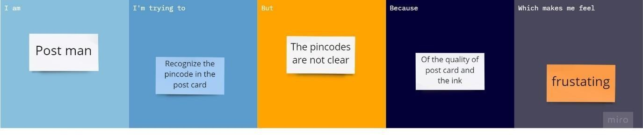

Example 2:



Example 3:

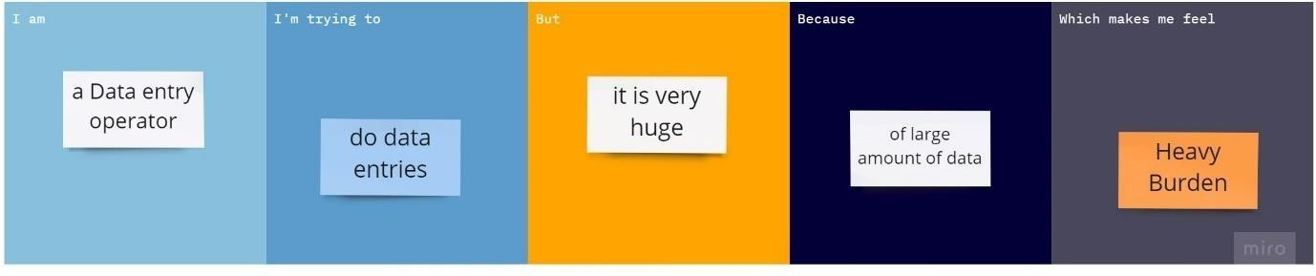

Example 4:

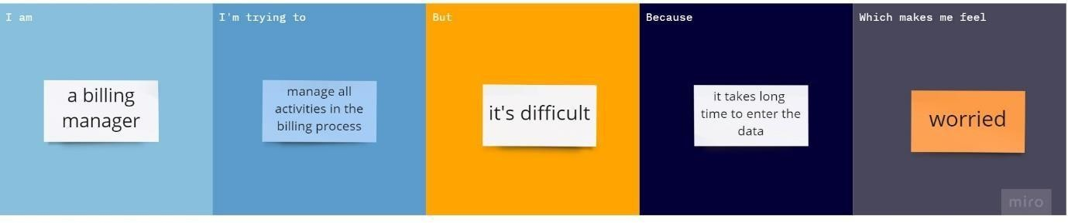

Example 5:

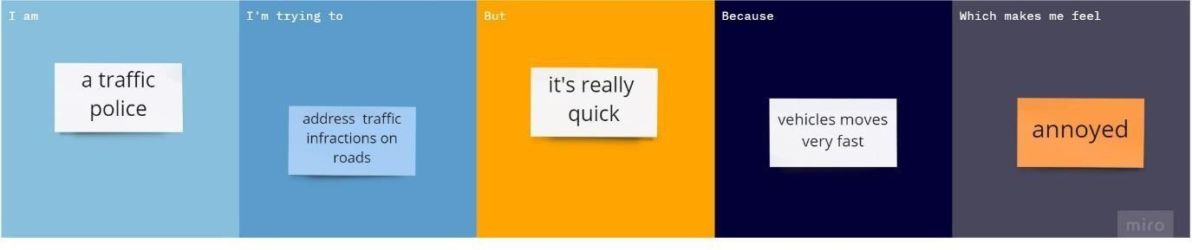

|  |  |  |  |  |  |
| --- | --- | --- | --- | --- | --- |
| **Problem Statement (PS)** | **I am (Customer)** | **I’m trying to** | **But** | **Because** | **Which makes me feel** |
| PS-1 | Post Man | Recognize the pincode in the postcard | The pincodes  are not clear | Of the quality of post card and the ink | frustating |
| PS-2 | Bank Manager | Recognize the digits in Cheque | Digits are not clear | Unique style of handwritten of  digits by customers | Irritating |
| PS-3 | Data Entry operator | Do data entries | It’s very huge | Of large amount of data | Heavy burden |
| PS-4 | Billing Manager | Manage all activities in  billing process | It’s difficult | It takes long time to enter the data | worried |
| PS-5 | Traffic Police | Address traffic infractions on  roads | It’s really  quick | Vehicles moves very fast | Annoyed |